PAI Ticket Engine — Process Overview
This document demonstrates the workflow of the PAI Ticket Engine, from loading the file to executing queries.

Step 1: Loading the file using the 'load file' command.
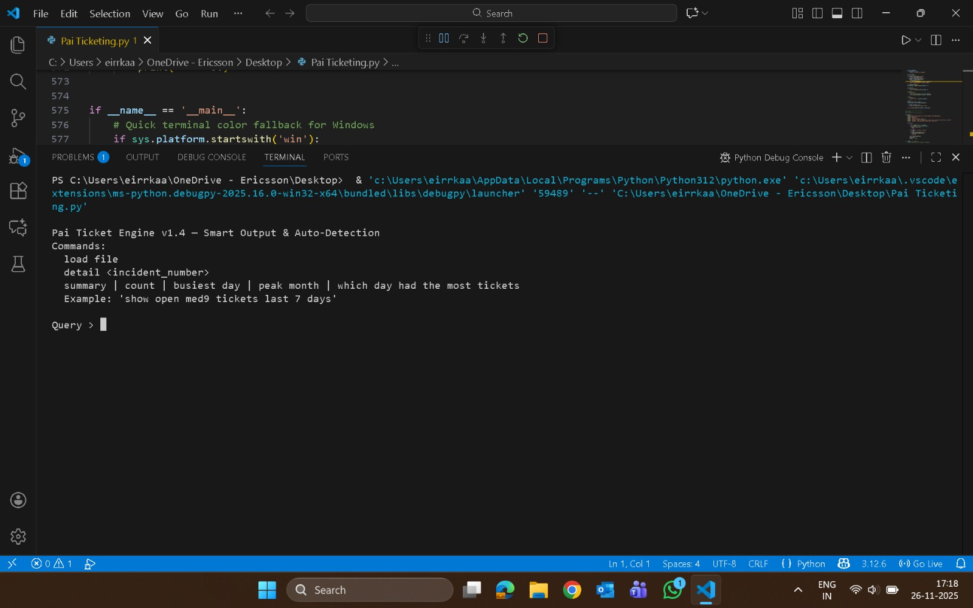

Step 2: File picker popup appears, allowing file selection.
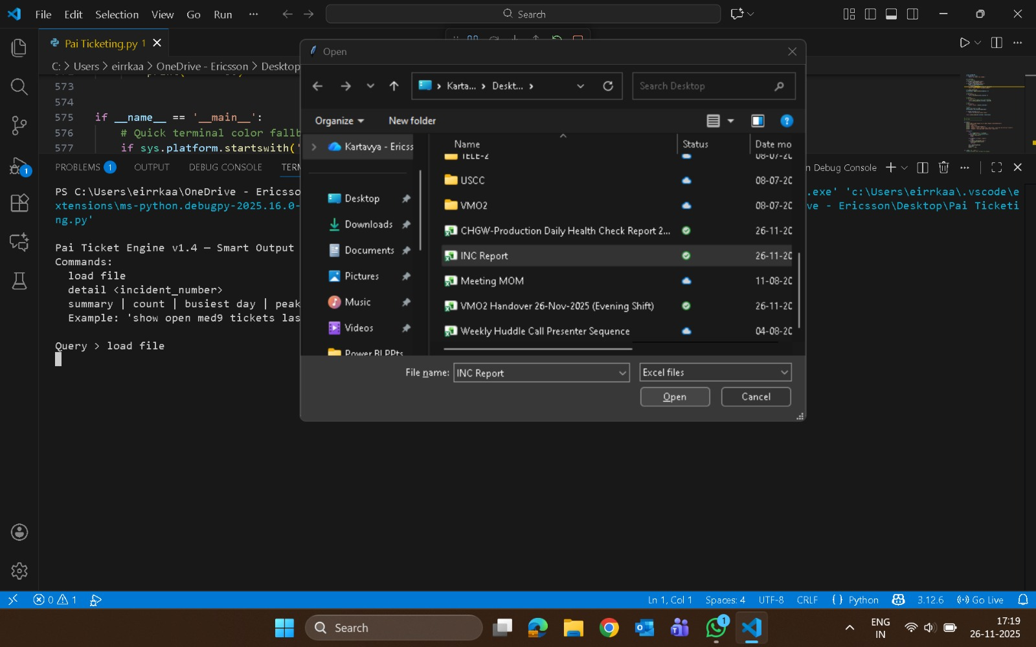

Step 3: First query execution showing resolved medium priority tickets.
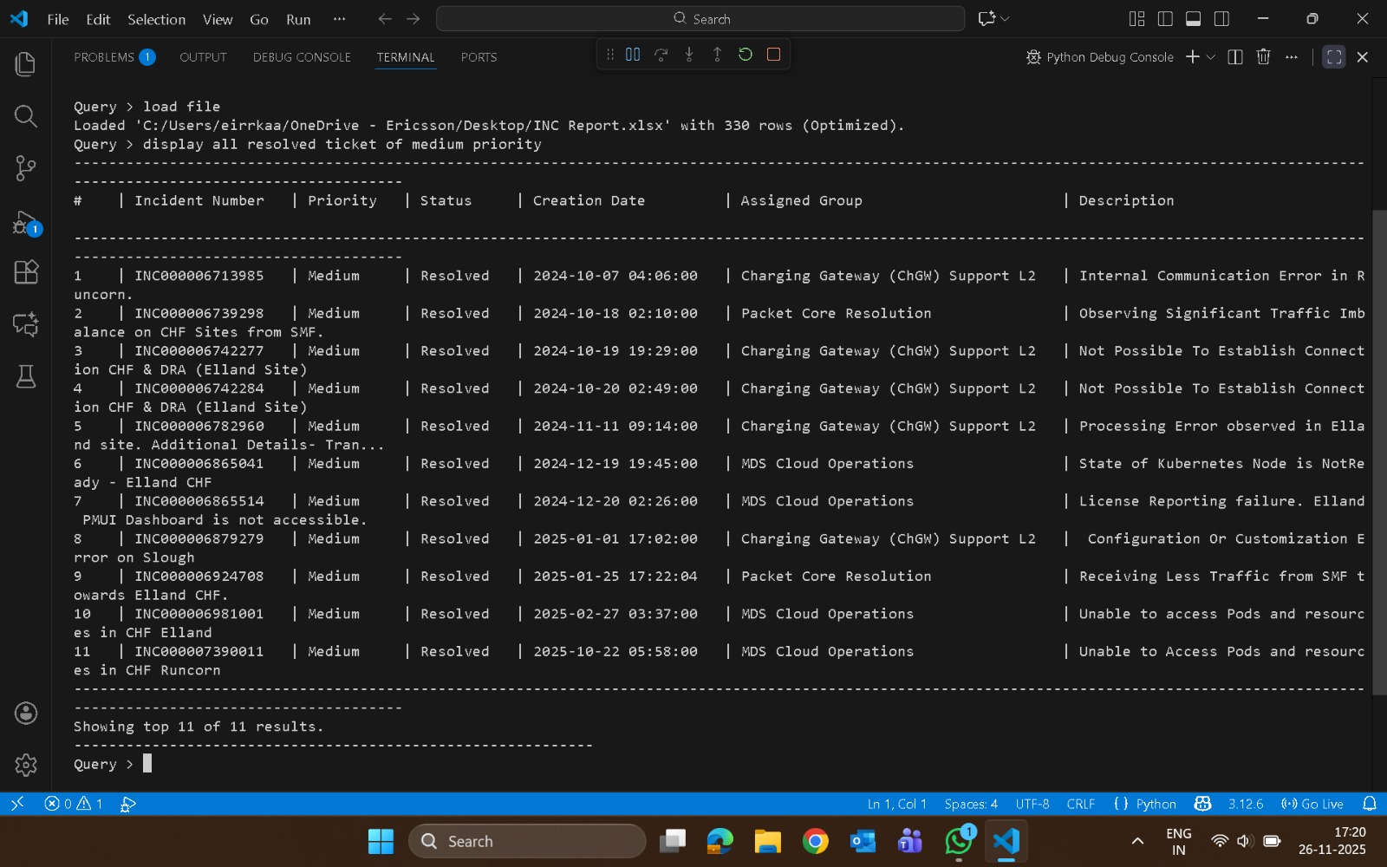

Step 4: Additional queries displaying group-based summaries.
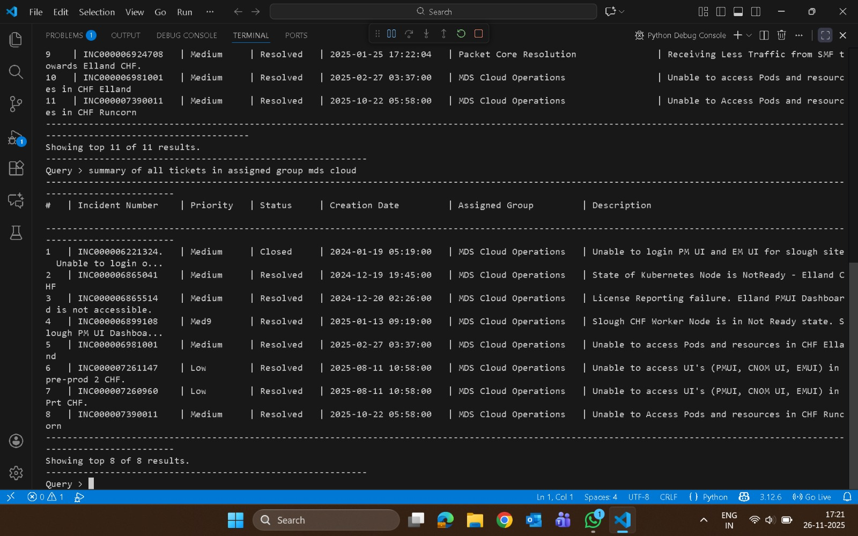

Step 5: Displaying tickets resolved in the last 10 days.
